
INTERNATIONAL CYBERSECURITY AND DIGITAL FORENSICS ACADEMY

ASSIGNMENT

Assignment Title: Number Systems, ASCII, Timestamps and Data Representation
Student Name: Ahmad Zubairu Garba
Student ID: 2025/FWSD/11463
Course Title: Basic Computer Skills for Digital Forensics
Course Code: SBT-DF201
Instructor: Aminu Idris

August 09, 2026
INTRODUCTION
The goal of this laboratory exercise is to build foundational command-line discipline, evidence documentation habits, and repeatable workflow steps using the Windows Command Prompt. Rather than investigating an active security incident, this lab establishes core competencies in navigating the Windows file system, managing evidence directories, executing basic text searches, collecting hardware/network/process triage artifacts, and developing reusable automation batch scripts.
Environment
- Operating System: Windows 11 Host / Training Virtual Machine
- Execution Interface: Windows Command Prompt (cmd.exe) and Notepad
- User Privilege Level: Standard User / Administrator (for PATH configuration)
- Lab Workspace Directory: C:\Users\Public\CIP-B101_Lab1C_Ahmed_Garba
Methodology
Establishing the Evidence Workspace
A dedicated, isolated workspace was established within the public user directory to ensure that all artifacts, evidence files, scripts, and logs remained neatly organized and partitioned from critical operating system files.
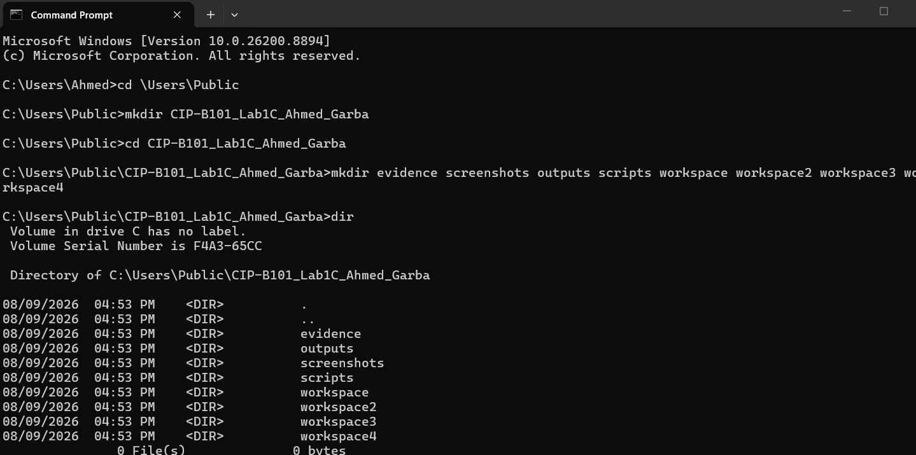

Task 1: Windows Paths and Navigation
To understand file-system layout and evidence localization, directory traversal was performed using both absolute and relative paths.
- Display current location:
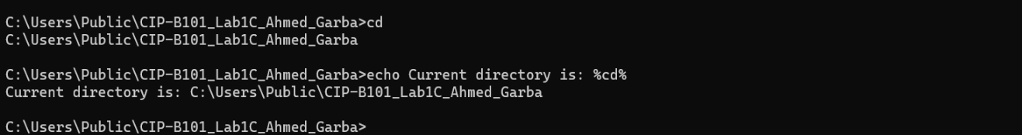
Navigate to root and specific paths:
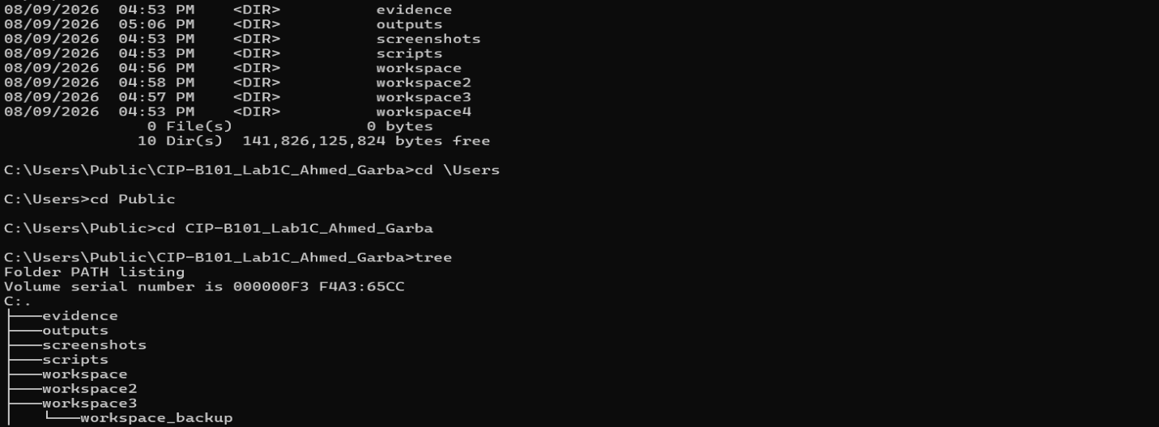
Task 2: Basic File and Folder Creation
Evidence note creation and file content generation were practiced inside the designated workspace subdirectory.
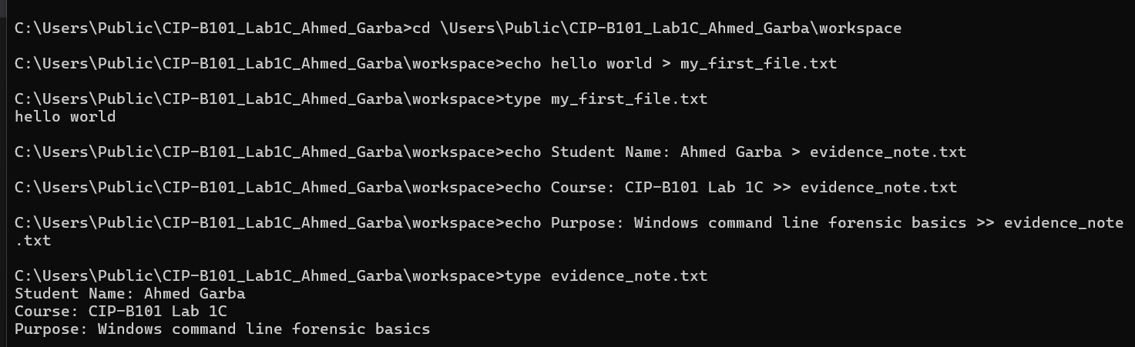

Task 3: Safe File and Folder Handling (Copy, Rename, and Delete)
Controlled duplication, backup, renaming, and selective deletion were executed to simulate careful evidence handling protocols.
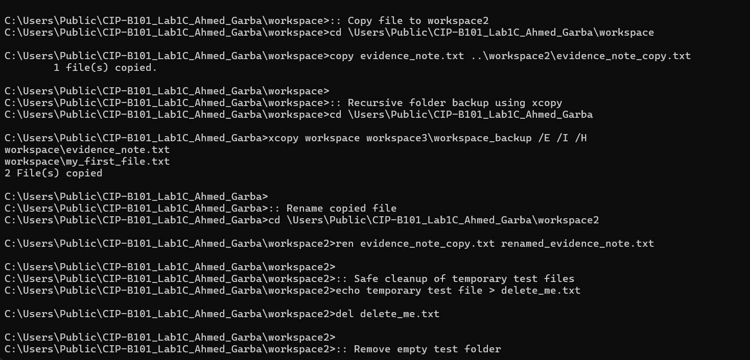
Task 4: Understanding Windows Search Pathways (PATH Variable)
System executable lookup behaviors were examined to understand how the operating system locates binaries and why PATH manipulation is relevant during forensic triage.
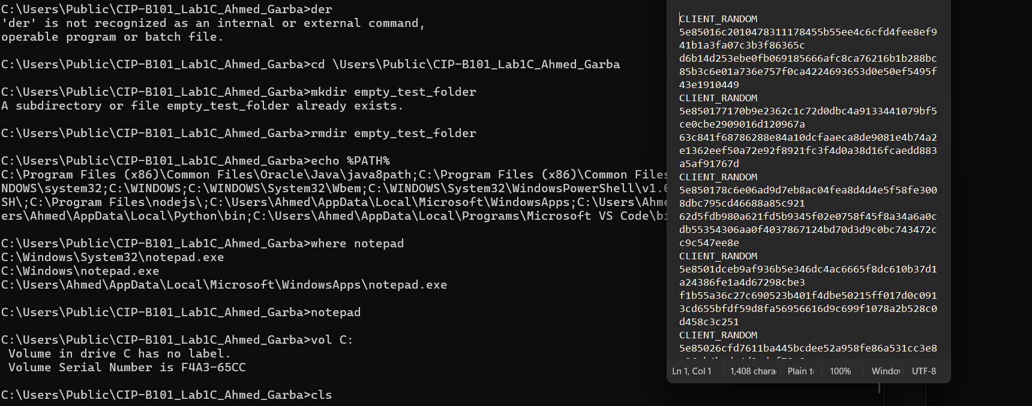

Task 5: System Information Collection
Host configuration artifacts commonly required during initial triage documentation were harvested and stored in the outputs directory.
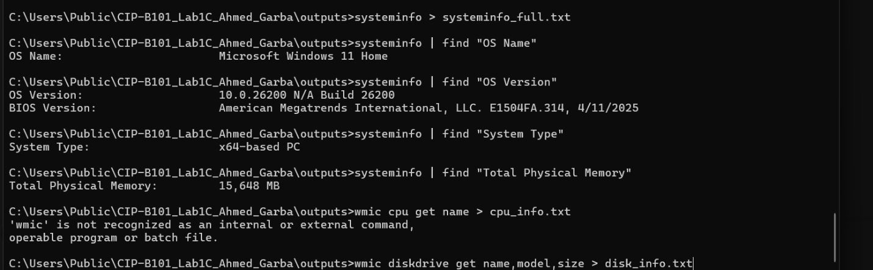
Task 6: Network Information & Connectivity Collection
IP configurations, gateway mappings, MAC address enumerations, and loopback/external connectivity checks were performed.
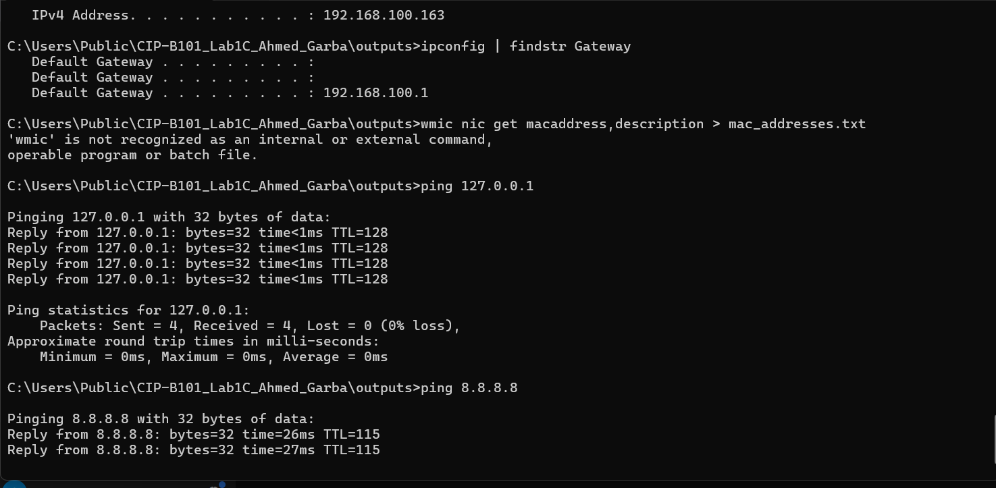
Task 7: Searching Text Files for Evidence (findstr)
A mini case log was generated to simulate searching parsed artifact files for specific indicators of compromise or keywords.
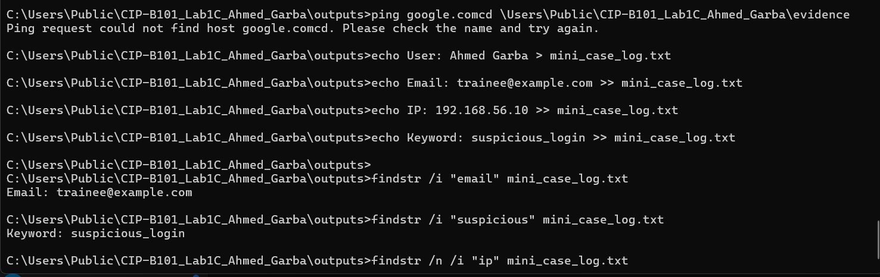

Task 8: File Ownership and Permissions Check
File metadata, ownership, and discretionary access control lists (DACCs) were examined.
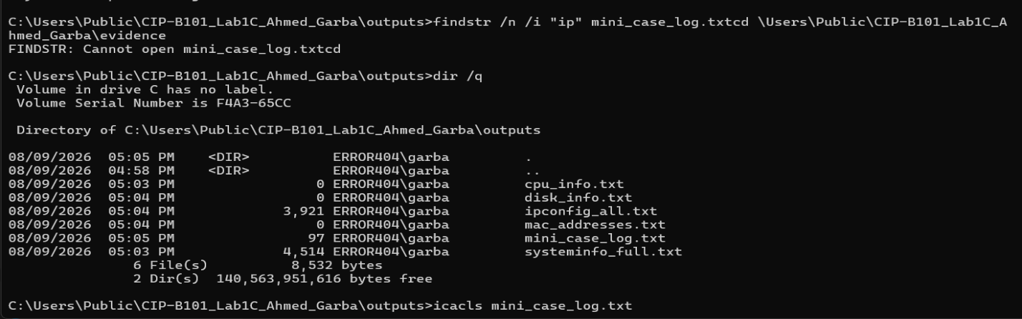
Task 9: Process Listing and Browser Process Identification
Running processes were queried to identify active user applications and background execution states.
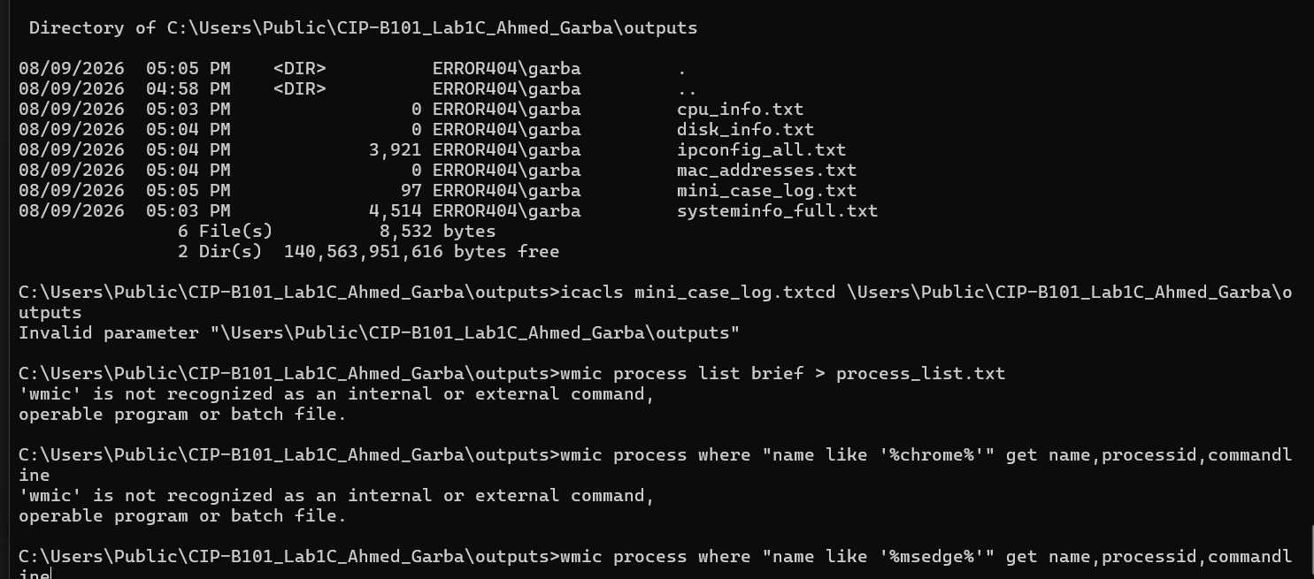
Task 10: Batch File Creation and Execution
10.1 hello_world.bat
Created inside the scripts folder to verify execution capability:
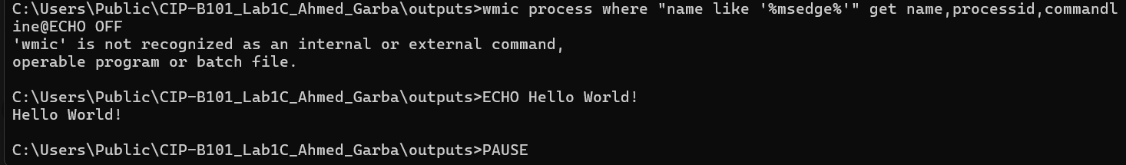
10.2 sys_info.bat
Developed as a reusable triage automation script:
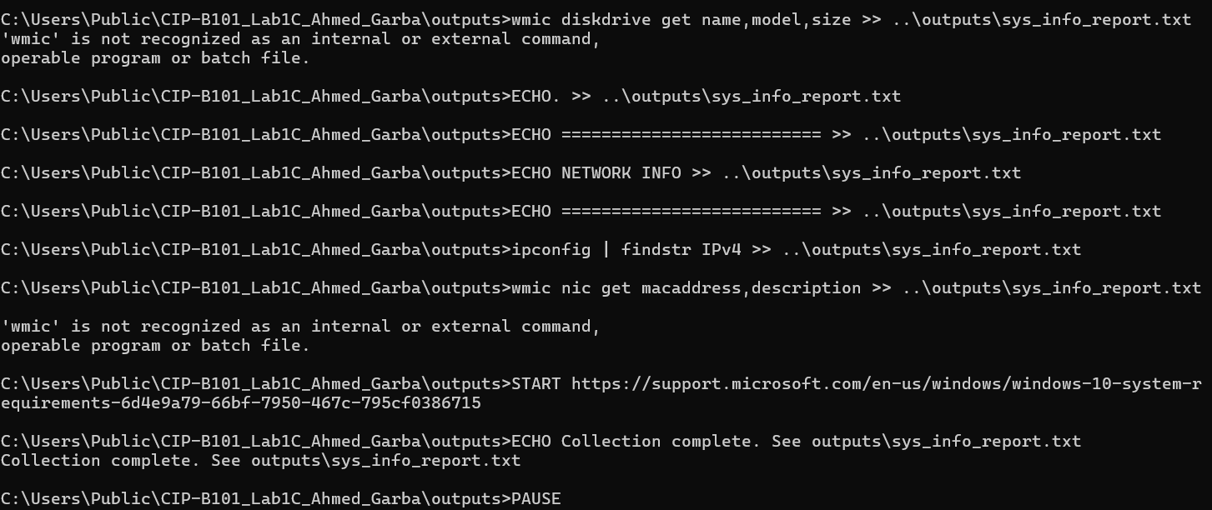
Task 11: Making sys_info.bat Globally Callable via PATH
To ensure scripts can be executed from arbitrary directories without specifying absolute file paths, the environment PATH variable was temporarily updated:
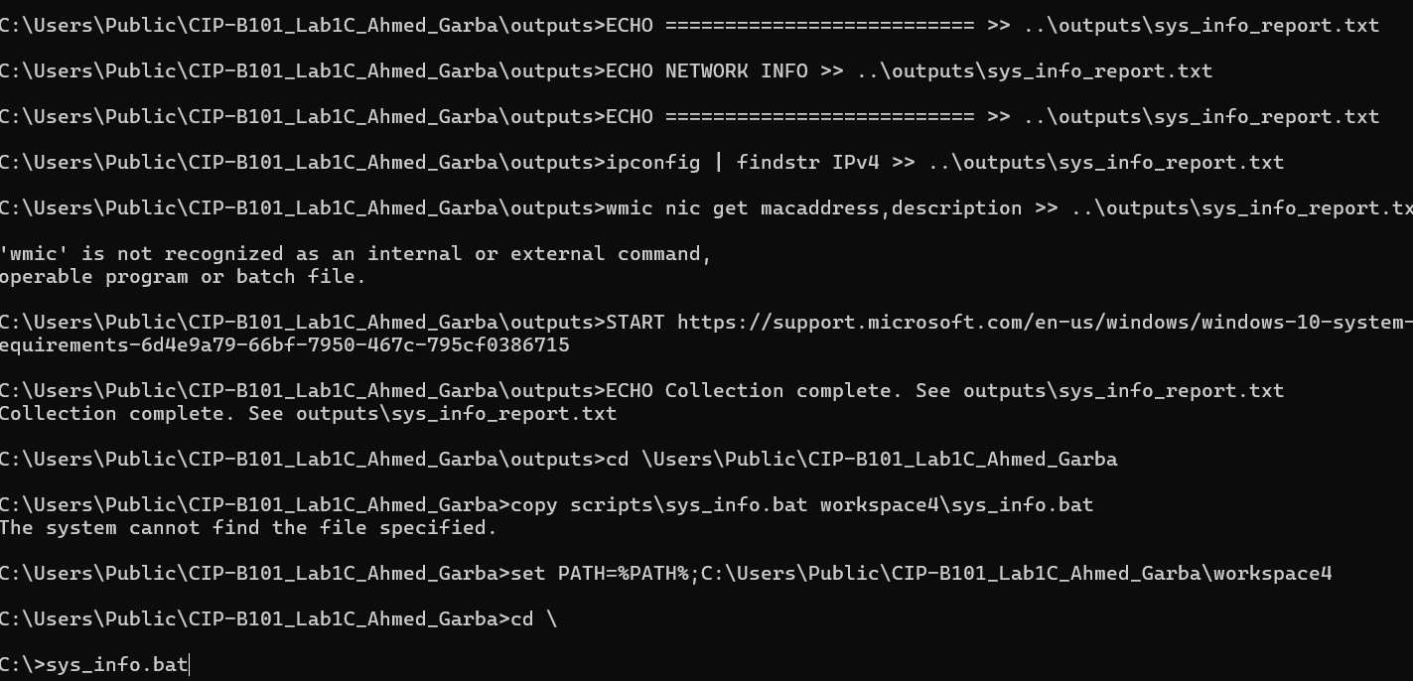
What is the difference between an absolute path and a relative path? Give one example of each from your lab.
Absolute Path: Specifies the complete location of a file or directory starting from the root drive (e.g., C:\Users\Public\CIP-B101_Lab1C_Ahmed_Garba).
Relative Path: Specifies a location relative to the current working directory (e.g., ..\workspace2\evidence_note_copy.txt).
Why should analysts create a separate lab/evidence folder before running commands?
Creating an isolated workspace prevents accidental modification, overwriting, or deletion of critical operating system files or pre-existing case artifacts, ensuring strict chain-of-custody and organization.
Which command showed your IP address and which command showed your MAC address?
IP address information was retrieved using ipconfig (or ipconfig | findstr IPv4).
MAC address information was retrieved using wmic nic get macaddress,description.
Why is a batch file useful in forensic triage?
Batch scripts automate repetitive, multi-step triage procedures, minimizing human error, standardizing data collection across multiple workstations, and accelerating evidence acquisition during time-sensitive investigations.
Why must analysts document failed commands or failed pings instead of hiding them?
Complete transparency is vital for forensic integrity. Failed pings or errors provide crucial environmental context (e.g., network isolation, disconnected adapters, or missing privileges) that investigators and reviewers must account for.
What risk can occur if a suspicious executable is placed in a directory listed in PATH?
If a malicious binary shares the name of a standard utility (or relies on PATH hijacking/DLL preloading vectors), the operating system may inadvertently execute the unauthorized program when a user or script invokes the command without a fully qualified path.

CONCLUSION
This practical laboratory successfully reinforced core Windows command-line operations essential for digital forensics. By establishing structured workspaces, executing system and network triage queries, automating artifact collection with batch scripts, and managing execution paths, foundational technical proficiency and documentation discipline necessary for advanced forensic investigations were achieved.

